Day 3 : 11 Oct 2024 CB FSD - Planning and UI Design

Creating token in github, which help us to clone as well as connecting local to remote repository.

1. git clone URL

git clone https://token@github.com/Kaleakash/caltech_test_repository.git

steps to create the token

right corner in git hub account -> setting 🡪 developer setting 🡪

Personal access token 🡪 token (classic) 🡪 generate new token classic 🡪

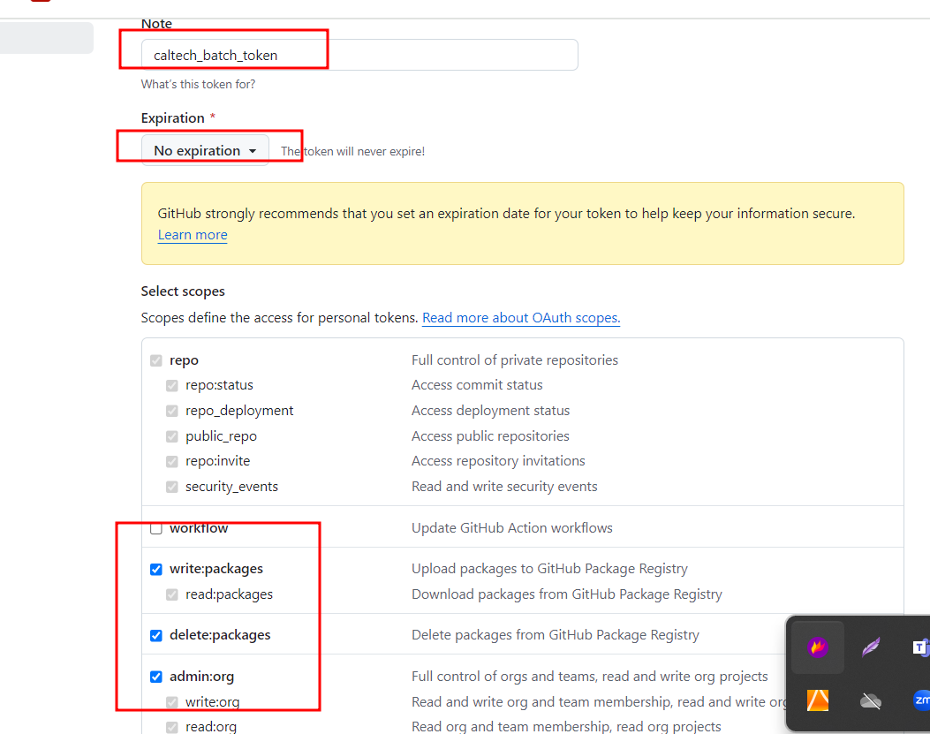

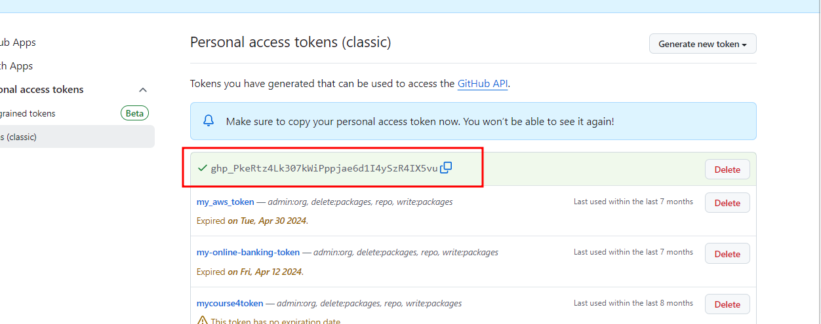

git clone

clone other user or authors repository in our local machine or VM.

mkdir trainerrepository

cd trainerrepository

git clone <https://github.com/Kaleakash/caltech_test_repository.git>

this command is use to download the fresh repository in local or vm machine.

This command you need to execute inside repository folder.

git pull in existing other person repository pull new update present tin remote repository.

open the terminal

mkdir demoapp

cd demoapp

this command is use to download fresh repository

git clone <https://github.com/Kaleakash/caltech_test_repository.git>

cd caltech_test_repository.git

then open vs code

code .

to get new updated in existing repository you need to run the command as

git pull

if you are planning to do any changes don’t do in master/main branch

please create user defined branch

git branch mybranch ie mybranch user defined branch name

git branch to verify all branches present in local machine

git checkout mybranch this command is use to switch to user defined branch

then do some changes in user defined branch mean delete file, update file or create new file etc.

git add .

git commit -m “done some changes”

now switch to main branch

git pull

SDLC : Software Development Life cycle : SDLC is structured process used to design, develop and test high quality software.

Planning :

* Understand the project or application or app goal, scope, requirement and constraints.
* Cost, timeline and resources etc.

Requirement gathering and Analysis :

* Collect detailed software requirement from stakeholder.
* Document and analysis these requirement to ensure feasibility.

Design

* Convert these all requirement into blueprint for the system architecture. Flow chart OR UML
* Define database design (ER-Diagram) , user interface and software component.

Development

* Actual coding base upon the design using different language.
* Developer need to write the base upon standard design pattern.

Testing

* Test the software to identity the error and fix the bugs.
* Ensure that the software meet all functional as well as non functional requirement base upon client.

Deployment

* Release the software or application to the production environment.
* The software is installed and mode available for use.

Maintenance

* Monitor the software or hardware issue and provide the support.
* Handle update, patch and improvement. etc.

Agile